**DOCKERFILE**

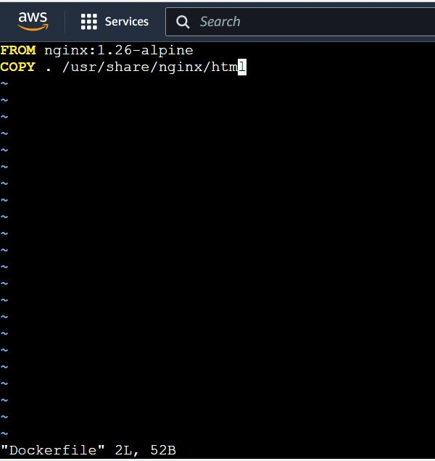

**HTML CODE**

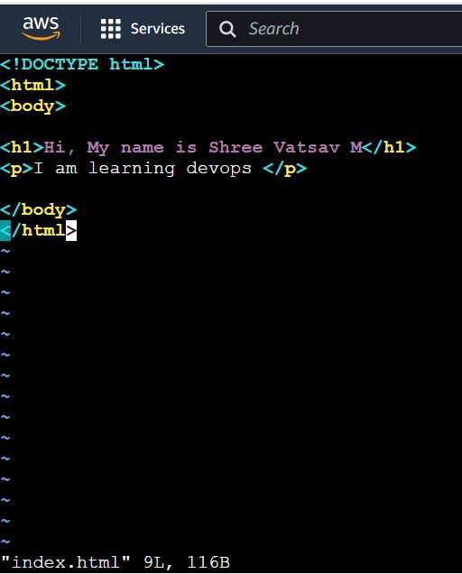

**COMMANDS TO BUILD DOCKER IMAGE**

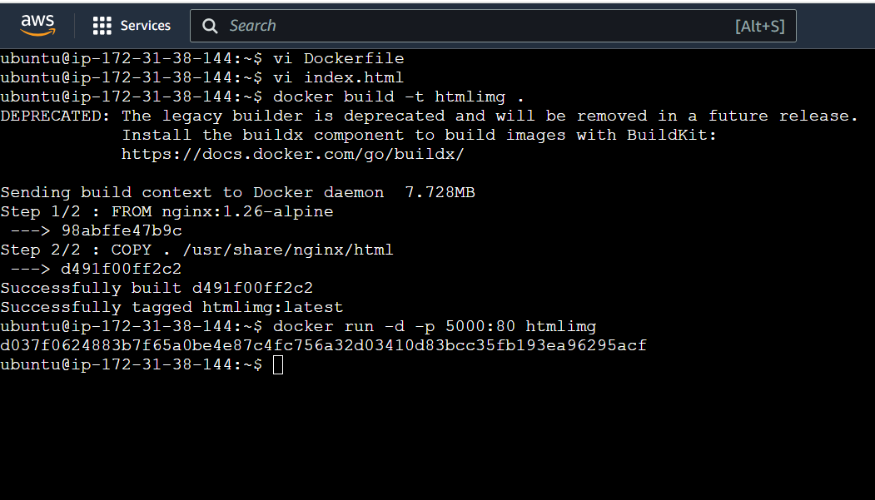

**OUTPUT**

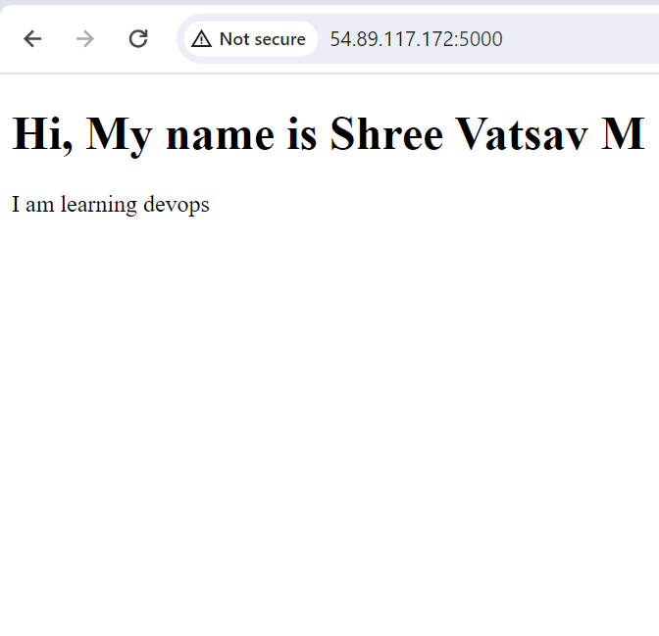 **link to access** - http://54.89.117.172:5000/